

MOCK 2026 – 2 ½ Hours

Name ……………………………………..………………..Class ………Adm no…..………

Index no. ………………….……… Candidate’s signature ………….....…………………
COMPUTER STUDIES MS
451/1
Paper 1 (THEORY)
FORM FOUR 2026
SECTION A (40 MARKS)
Answer all questions in this section
- Name the stage of systems development life cycle where an interview is used.
Analysis (1mark)

- Differentiate between word wrap and wrap text as used in Microsoft word (2marks)
Word wrap is feature that automatically carries forward the last character/word to the beginning of the next line while wrap text is a feature that dictates how text orientates around an object (picture/shape) e.g. tight, behind, in front etc.
- List down two functions of return key on the keyboard. (2mark)
To start a new line/paragraph in word processing
To execute a command
- a). What is meant by the term data integrity (1mark)
The correctness
b). Password is a secret code for protecting documents against unauthorized access. State three features of a strong password (3marks)
- Should have mix of characters
- Should not be too short
- should not be too easy to guess
- The first column in the table below contains the formula stored in cell C10 of a spread sheet. Enter the formulae as they would appear when copied to cell F15 of the same spread sheet. (3 marks)
FORMULA IN C10 | FORMULA IN F15
=A5*B5 | D10*E10
=E$5 | H$5
= 4*$B6 | 4*B9
- State three advantages of a computer network. (3 marks)
-Easy and faster communication
-Easy to share data and other resources
- Easy to extend with increase in workload (scalable)
- Describe the following factors which are used in the selection of software. (2marks)
(i.) Authenticity
Sourced from the genuine proprietor
(ii.) Portability
-Can be installed/used in more than platform/computer
- A student in a school wanted to print a document but the printer could not print yet the printer was on and the papers were correctly placed. Name any other three possible reasons why the printing failed. (3 marks)
- Check the data cable to ensure it is properly connected
- Check that the printer connected is the one selected
- Check that the printer queue does not have pending jobs
- State two advantages of USB ports over LPT and COM ports. (2 marks)
- Has higher speeds of communication
- Can connect many devices (up to 2⁸ devices)
- Can perform both data and power transmission
- James was sent to buy computers for the school laboratory. He was supposed to take into account the following factors:
- Processor speed
- Memory capacity
- Compatibility
State three main reasons for taking into account the above factors. (3 marks)
- Processor speed – the higher the speed the better the performance
- Memory capacity – the higher the capacity the better the performance
- Compatibility – should be capable to be used by different devices and software
- List three things that should accompany a newly purchased software. (3marks)
- Licence/End user licence
- User manual
- Technical manual

- Name three types of non-printing guides in PageMaker. (3 marks)
- Column guides
- Ruler guides
- Margin guide
- Baseline guide
- Row guide
- State three responsibilities of a computer technician. (3 marks)
-Installation of computer
- Installation of software
- Repair/replacement of hardware.
- Troubleshooting of hardware/software.
- Configuration of network
- a) Describe an entity relationship diagram (ERD) in database design. (2 marks)
A diagrammatic representation of entities/tables and how they are connected.
Accept diagrams/illustrations
- Differentiate between Batch and Real-time data processing modes. (2 marks)
-Batch processing the user cannot interruct with the data once processing begins while real time processing, the user can interruct with the system at any stage.
Batch processing data is accumulated over a period of time while real time processing data is processed immediately it is received.
- Name two features of word processors. (2 marks)
- Word wrap
- Formatting features
- Editing features
SECTION B 60 MARKS
16. (a) Dry running refers to testing a code manually using pen and paper.
(b)
  - An algorithm must have a definite start and end point.
  - An algorithm should accept zero or more inputs and produce at least one output.
  - Every step in the algorithm must be clear and precise. There should be no confusion about what action to perform at each stage.
(c)
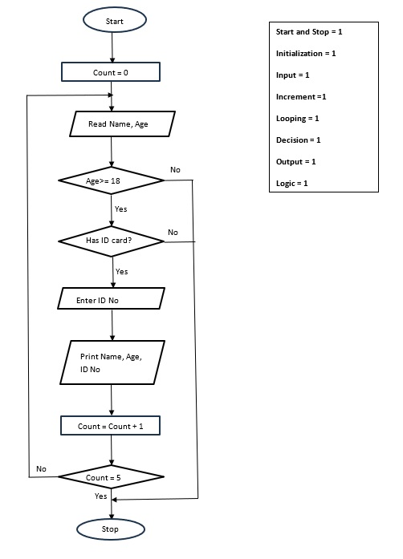

17. a. Briefly describe the following terms as used in a spreadsheet. (4marks)
- Cell
The intersection of a row and column
- Argument
The input value or piece of information passed to a function/formula, e.g.
=countif(A1:B12, ”Good”) has two arguments, the range (A1:B12) and the condition, “Good”.
- Chart
A pictorial representation of spreadsheet data.
- Sheet
A single page, tab, or grid within a spreadsheet file where work is entered.
b. List six page-formatting features of word processors. (3marks)

- Margins
- Orientation
- Size
- Column
- Breaks
- Headers/Footer
- Background

c. Differentiate between the term printing of multiple pages and multiple copies. (2marks)
- Multiple pages – same page a number of times.
- Multiple copies – several copies of the same page/document
d) Distinguish between a worksheet and a workbook (2marks)
-Worksheet – a single tab/grid in a spreadsheet file
- Workbook – a spreadsheet file
e). Describe four parts of a form in a form design view in a database. (4marks)
1. Form Header Appears only once at the very top of the form; used for titles
2. Page Header – The content will appear at the top of every printed page if the form is printed
3. Detail -The core section where data records are displayed; contains the text boxes and labels linked to fields.
4. Page Footer – This appears at the bottom of every printed page; typically holds dates, times, and page numbers.
5. Form Footer: Appears only once at the very bottom of the form; used for command buttons, totals, or summary data.

18. (a) The following is an extract from a database obtained from a National organization. Use the table to answer questions which follow:
S/NO | EMPLOYMENT ID | NAME | AGE | DEPARTMENT | STATUS
001 | EMP01 | Lucy | 40 | Secretary | Married
002 | EMP02 | Agnes | 45 | Cook | Single
003 | EMP03 | Peter | 30 | Messenger | Married
004 | EMP04 | Joel | 35 | Account | Married
- Name the data type for each field. (3 marks)
FIELD NAME DATA TYPE
S/NO – NUMBER/TEXT
EMPLOYMENT ID- TEXT
NAME – TEXT
AGE- NUMBER/TEXT
DEPARTMENT – TEXT
STATUS - YES/NO, LOOKUP/TEXT

b) (i.) What is meant by the term candidate key? (2marks)
A unique field/key or a set of unique keys
(ii.) Which field could best fit to be a primary key? (1mark)

S/NO OR EMPLOYMENT ID
(iii) Explain your answer in (ii). (2 marks)
S/NO OR EMPLOYMENT are unique i.e. no two records bear the same s/no value or employment id
- Illustrate a query to extract all the details of those who are 30 years and above and are married. (5 marks)
FIELD
 |  | AGE | STATUS
CONDITION |  | >=30 | MARRIED

AGE: >=30
STATUS: MARRIED
- State two circumstances under which a questionnaire is best suited for data collection. (2 marks)
- When you need to gather information from a large, geographically dispersed population o
2. When the study requires anonymous, highly standardized data to maintain privacy and objectivity
19. (a) Describe a ring topology in computer networks. (2marks)
A ring topology is a local area network (LAN) structure where each device connects to exactly two neighboring devices, forming a continuous, closed circular pathway for data.
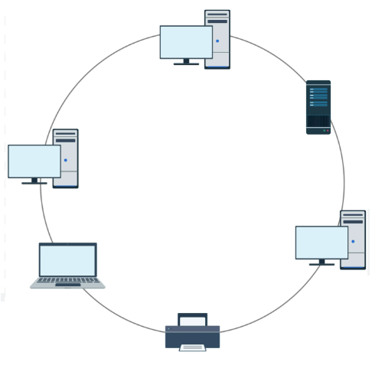

Accept illustrations.

(b)
7 - 4
4₁₀ = 0100₂
7₁₀ = 0111₂
Padding
4₁₀ = 00000100
7₁₀ = 00000111
1st complement = 11111011 2nd complement = 11111011 + 1 = 11111100 = 11111100
00000111 + 11111100 = 100000011₂
Ignore overflow bit 00000011₂ or 11₂

Awarding Marks
Conversion to binary: 1 mark (0.5 marks each)
Padding: 1 mark (0.5 marks each)
Ones complement: 1 mark
Twos complement: 1 mark
Answer with overflow: 1 mark
Answer when overflow is ignored: 1mark

(c)
- 377₈ to hexadecimal (3marks) Convert to binary 1 mark
Convert to hexadecimal 1 mark
Correct answer 1 mark
3 7 7
011 111 111
011111111
= 0000 1111 1111
0 15 15
0 F F
= FFH or FF₁₆

- 50.4₁₀ to binary (4marks) 50 = B.P 32 16 8 4 2 1
G.P 32 16 2
1 1 0 0 1 0
= 110010₂
Marks Awarding
- Conversion of the integral part 1 mark
- Conversion of the decimal part 1 mark
- Correct answer without recurring accent 1 mark
- Correct answer without recurring accent 1 mark

0.4 X 2 = 0.8
0.8 X 2 = 1.6
0.6 X 2 = 1.2
0.2 X 2 = 0.4
0.4 X 2 = 0.8
= 0.0110₂

=110010. 0110₂
20. a). State three ways in which an operating system performs error handling in a computer system.
- Detecting errors.
- Informing users about the errors.
- Recovering from the errors where possible.
- Recording errors that occur and keeping a log of them.
- Initiate recovery of the errors.
- Have a database of all possible errors and appropriate error code or message.
- Keeps monitoring the hardware and software functionality for any error.
- Initiate an interrupt to the current task.
- Defines an error as fatal or non-fatal
- Displays an appropriate error message.

b) Simulation is one of the application areas of computers. What is meant by the term simulation? (2 marks)
Simulation is the process of creating a model or imitation of a real-world system, situation, or process to study, test, or predict its behavior without affecting the actual system.
- State three advantages of computer-based simulation. (3 marks)
• Reduces cost.
• Improves safety since it can be used in dangerous situation.
• Faster testing, training, and decision-making.

- The needs of the student.
- The level of training.
- Quality of training in the college.
- Cost of training.
- State two functions of a transaction file in data processing. (2 marks)
- Contains temporary data /current data.
- Update master file regularly.
- Used to enable current decision making.
- Acts as an audit trail
- State three measures that should be put in place in a computer laboratory to safeguard users’ health. (3 marks)
- Do not paint the laboratory using bright paint.
- Install fire extinguisher in the laboratory.
- Install an anti-glare screen.
- Equip the laboratory with standard furniture.
- Ensure proper ventilation.

In summary check for ergonomic, eye strain, physical safety and environmental hygene and electrical safey.

